[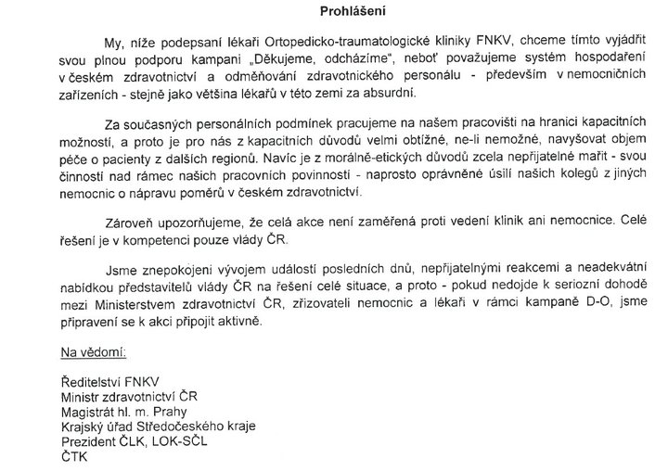](http://www.facebook.com/photo.php?op=1&view=global&subj=145078715527404&pid=410789&id=100001046283145&oid=145078715527404)

[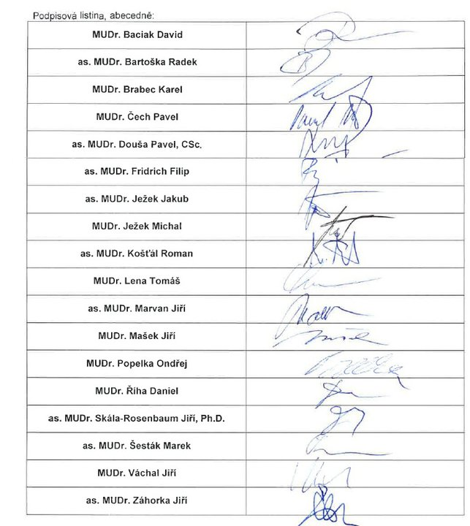](http://www.facebook.com/photo.php?op=1&view=global&subj=145078715527404&pid=8376313&id=706176207&oid=145078715527404)