[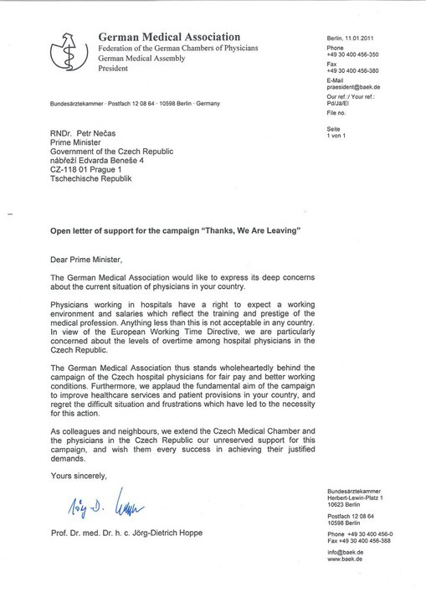](http://www.facebook.com/photo.php?op=1&view=global&subj=145078715527404&pid=6184224&id=694703896&oid=145078715527404)