[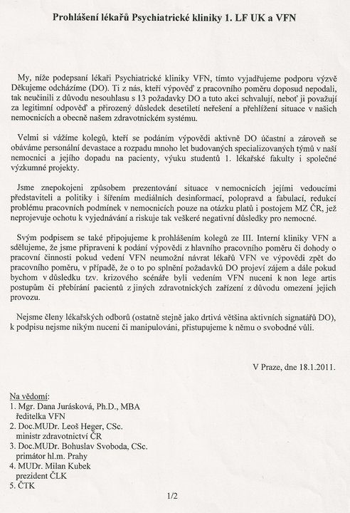](http://www.facebook.com/photo.php?op=1&view=global&subj=145078715527404&pid=31147843&id=1284411757&oid=145078715527404)

[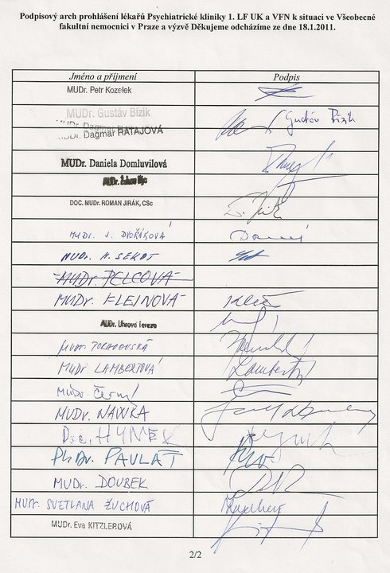](http://www.facebook.com/photo.php?op=1&view=global&subj=145078715527404&pid=327603&id=100000810718941&oid=145078715527404)