[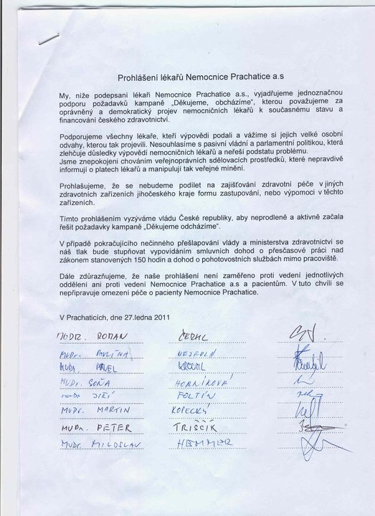](http://www.facebook.com/photo.php?op=1&view=global&subj=145078715527404&pid=197711&id=100001670755032&oid=145078715527404)

[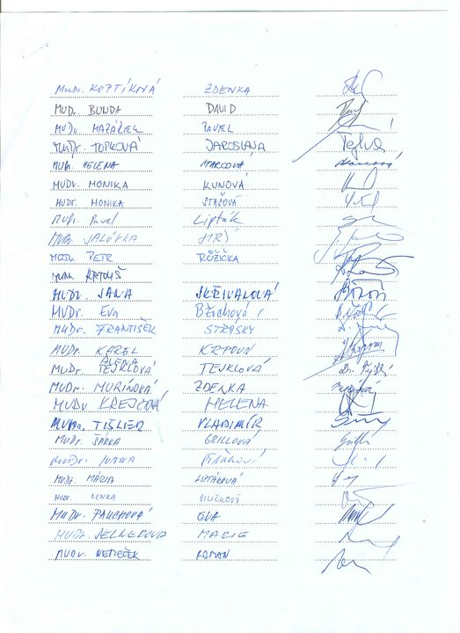](http://www.facebook.com/photo.php?op=1&view=global&subj=145078715527404&pid=814241&id=100000190837927&oid=145078715527404)